**Sanjith R**

**241059044**

**LINUX OS & SCRIPTING LAB**

**M.E – CYBER SECURITY**

**Getting Help**

1. **To get manual page for the known command:**
   * **Command Name**: man
   * **Syntax**: man [command]
   * **Example**: man ls
   * **Description**: This command displays the manual page for the specified command.

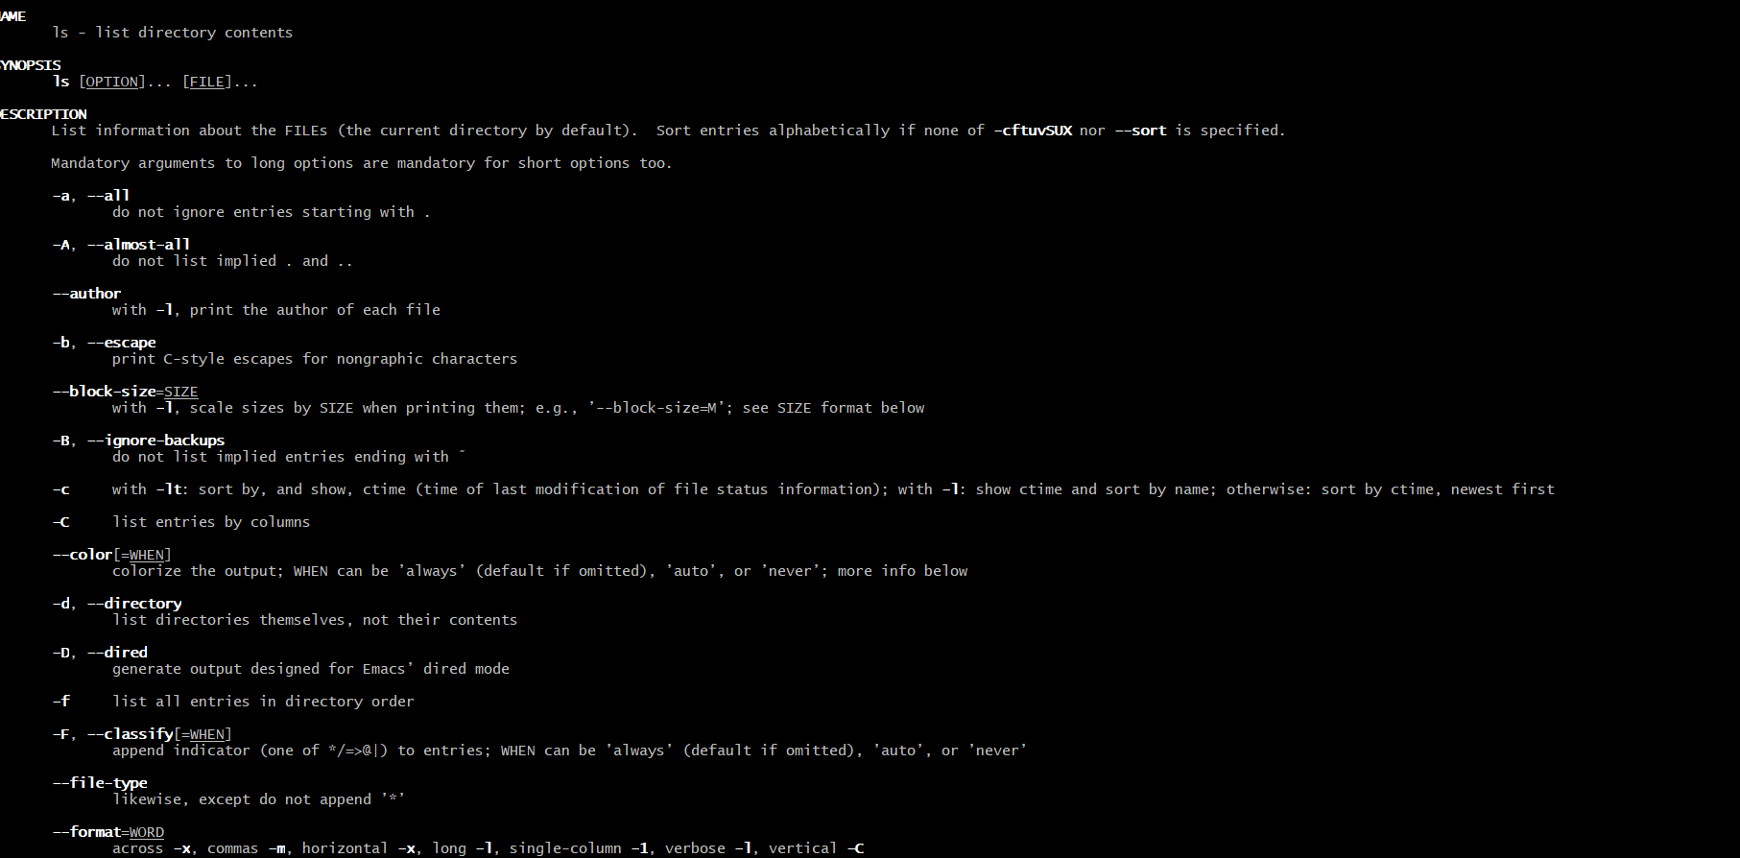

1. **To get manual page for the unknown command:**
   * **Command Name**: whatis
   * **Syntax**: whatis [keyword]
   * **Example**: whatis list
   * **Description**: This command provides a brief description of a command that matches the keyword.

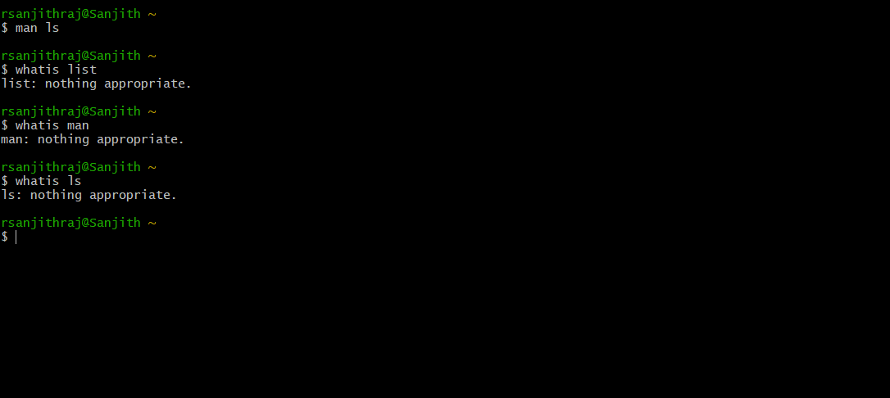

1. **To know the source file binary:**
   * **Command Name**: type
   * **Syntax**: type [command]
   * **Example**: type ls
   * **Description**: This command shows whether the command is a binary, an alias, or a shell function.

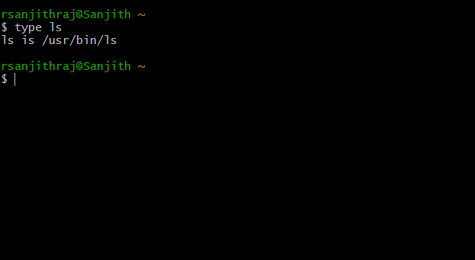

1. **To know the path of the command:**
   * **Command Name**: which
   * **Syntax**: which [command]
   * **Example**: which ls
   * **Description**: This command shows the full path of the command executable.

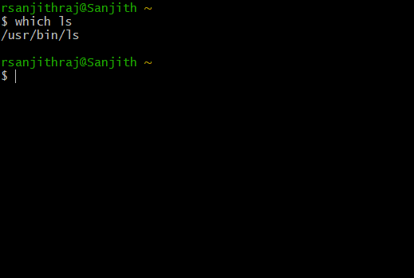

1. **To know if the command is external or internal:**
   * **Command Name**: type
   * **Syntax**: type [command]
   * **Example**: type cd
   * **Description**: This command tells if a command is a shell builtin (internal) or an external executable.

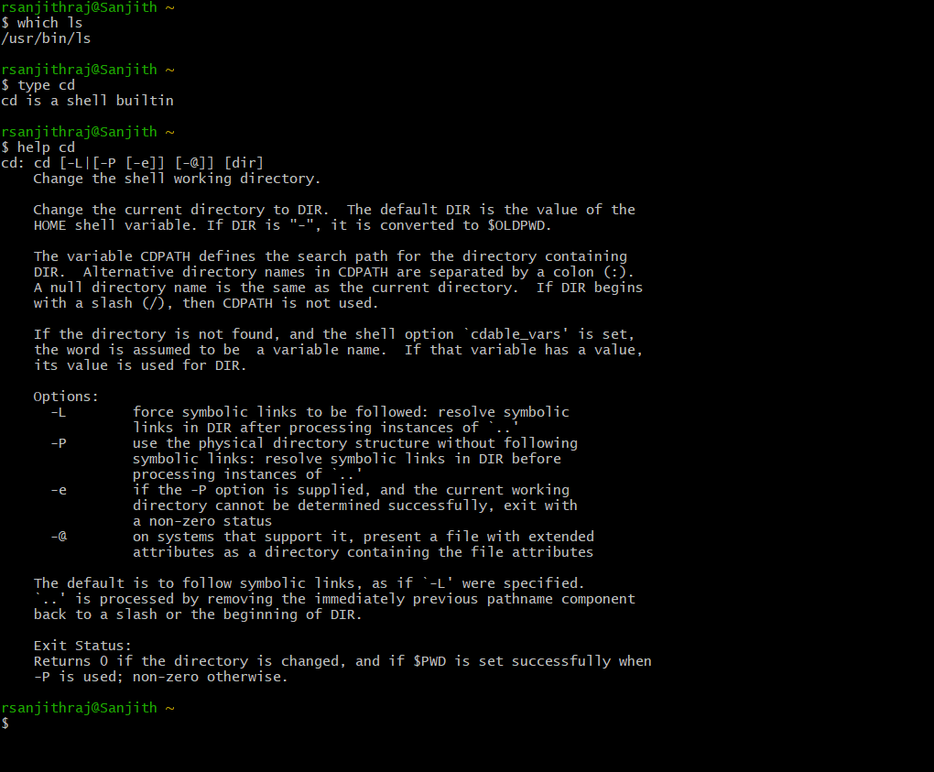

1. **To get help for the internal command:**
   * **Command Name**: help
   * **Syntax**: help [command]
   * **Example**: help cd
   * **Description**: This command provides help for shell builtin commands.



1. **To list out bash commands:**
   * **Command Name**: compgen
   * **Syntax**: compgen -c
   * **Example**: compgen -c
   * **Description**: This command lists all commands available in the current shell.

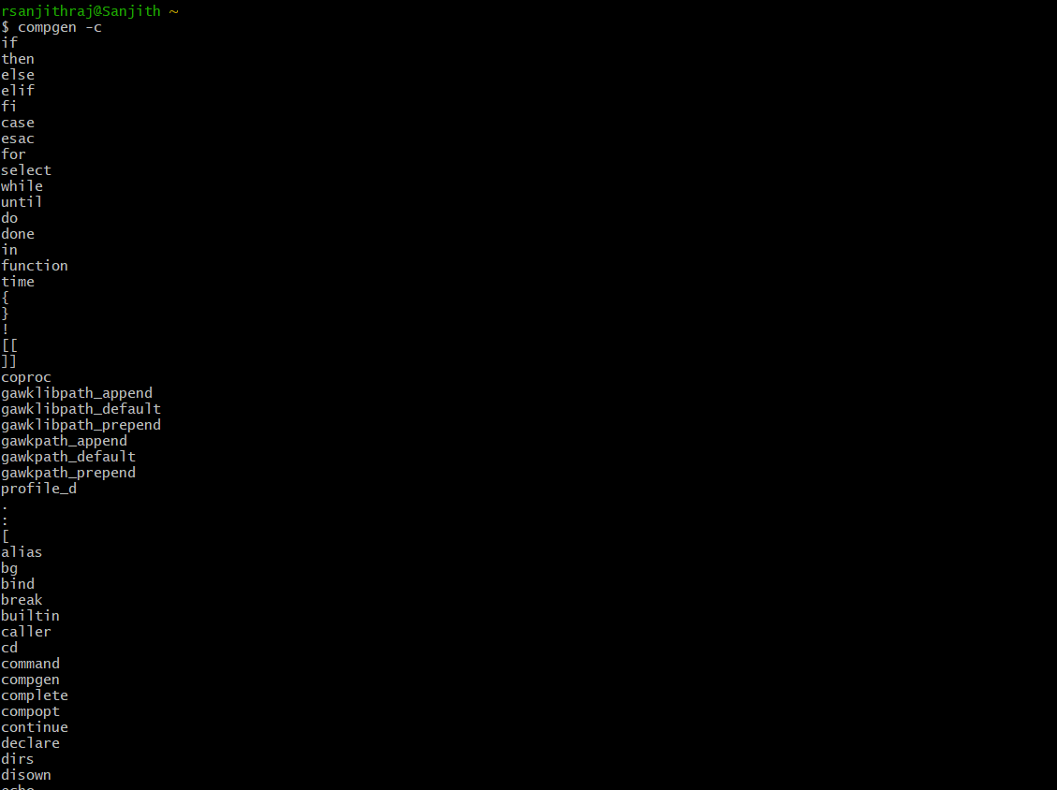

1. **To know the usage of the command:**
   * **Command Name**: command --help
   * **Syntax**: [command] --help
   * **Example**: ls --help
   * **Description**: This command provides a brief summary of the command options and usage.

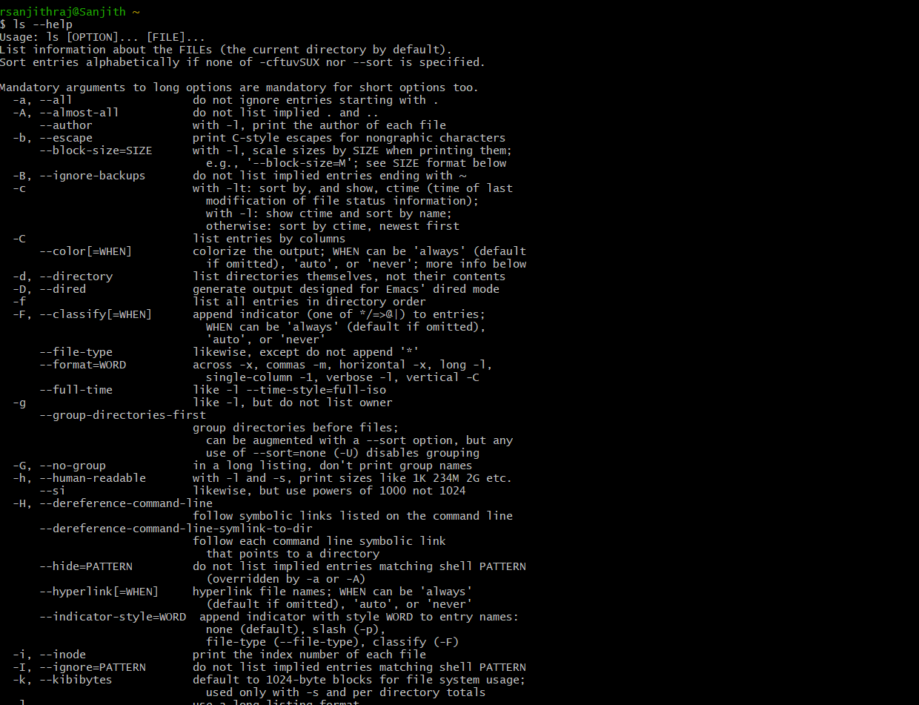

**Basic Commands**

1. **To know today’s date:**
   * **Command Name**: date
   * **Syntax**: date
   * **Example**: date
   * **Description**: Displays the current date and time.

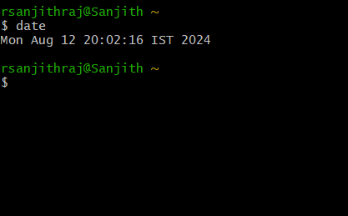

1. **To print calendar:**
   * **Command Name**: cal
   * **Syntax**: cal
   * **Example**: cal
   * **Description**: Prints the calendar of the current month.

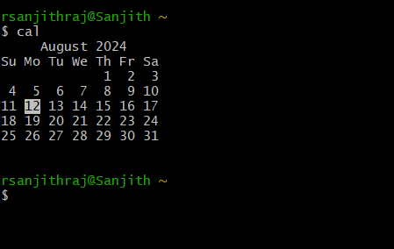

1. **To print kernel version:**
   * **Command Name**: uname
   * **Syntax**: uname -r
   * **Example**: uname -r
   * **Description**: Displays the kernel version of the system.

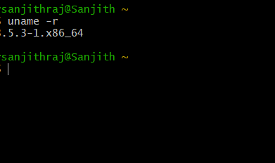

1. **To print default shell:**
   * **Command Name**: echo
   * **Syntax**: echo $SHELL
   * **Example**: echo $SHELL
   * **Description**: Displays the default shell being used.

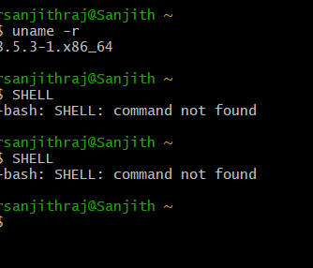

1. **To print currently logged in user:**
   * **Command Name**: whoami
   * **Syntax**: whoami
   * **Example**: whoami
   * **Description**: Displays the username of the current user.

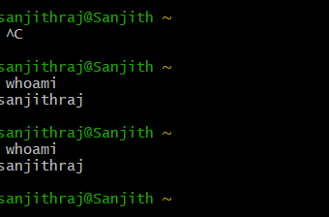

1. **To create a shortcut for a command:**
   * **Command Name**: alias
   * **Syntax**: alias name='command'
   * **Example**: alias ll='ls -la'
   * **Description**: Creates a shortcut for a command.

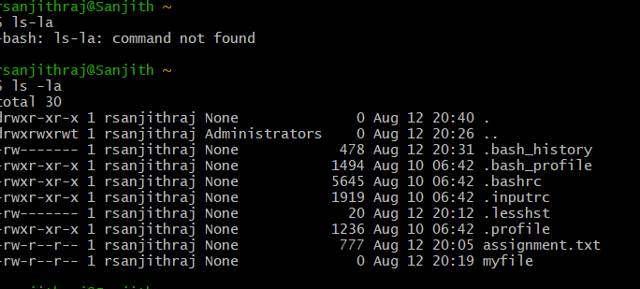

1. **To delete a shortcut:**
   * **Command Name**: unalias
   * **Syntax**: unalias name
   * **Example**: unalias ll
   * **Description**: Deletes an alias or shortcut.



1. **To change the timestamp of the file:**
   * **Command Name**: touch
   * **Syntax**: touch -t [YYMMDDhhmm] filename
   * **Example**: touch -t 2408071200 file.txt
   * **Description**: Changes the file's timestamp to a specified time.

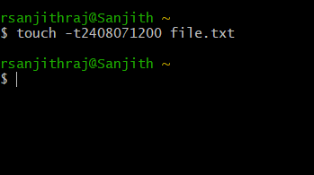

1. **To clear the screen:**
   * **Command Name**: clear
   * **Syntax**: clear
   * **Example**: clear
   * **Description**: Clears the terminal screen.

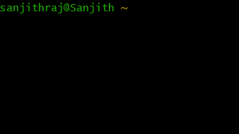

1. **To create empty files:**
   * **Command Name**: touch
   * **Syntax**: touch filename
   * **Example**: touch newfile.txt
   * **Description**: Creates an empty file with the specified name.

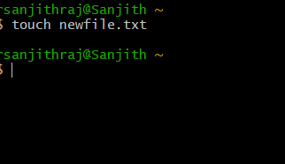

1. **To know disk usage:**
   * **Command Name**: du
   * **Syntax**: du
   * **Example**: du -h
   * **Description**: Displays disk usage of files and directories.

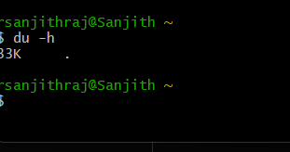

1. **To know free space in the system:**
   * **Command Name**: df
   * **Syntax**: df
   * **Example**: df -h
   * **Description**: Displays available disk space on file systems.

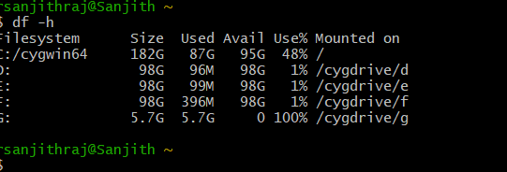

1. **To know about the Linux release:**
   * **Command Name**: cat
   * **Syntax**: cat /etc/os-release
   * **Example**: cat /etc/os-release
   * **Description**: Displays information about the Linux distribution.

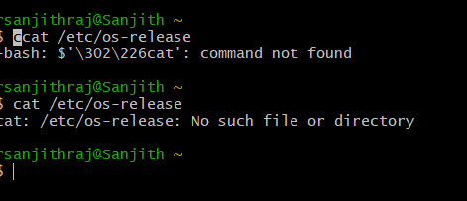

**Navigation**

1. **To navigate home directory:**
   * **Command Name**: cd
   * **Syntax**: cd ~
   * **Example**: cd ~
   * **Description**: Navigates to the user's home directory.

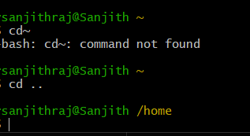

1. **To navigate to the parent directory:**
   * **Command Name**: cd
   * **Syntax**: cd ..
   * **Example**: cd ..
   * **Description**: Navigates to the parent directory.



1. **To navigate to the child directory:**
   * **Command Name**: cd
   * **Syntax**: cd [directory name]
   * **Example**: cd Documents
   * **Description**: Navigates to the specified child directory.

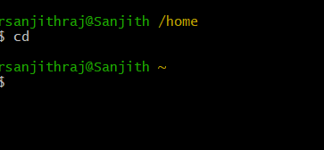

1. **Alternate command to cd:**
   * **Command Name**: pushd/popd
   * **Syntax**: pushd [directory] / popd
   * **Example**: pushd /var/log / popd
   * **Description**: pushd pushes a directory onto the stack and navigates to it; popd pops the directory off the stack.

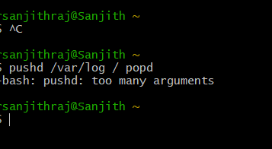

1. **To go back to the previous directory:**
   * **Command Name**: cd
   * **Syntax**: cd -
   * **Example**: cd –

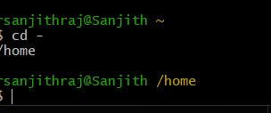

1. **Description**: Navigates to the previous directory you were in.
2. **To go to the root directory:**
   * **Command Name**: cd
   * **Syntax**: cd /
   * **Example**: cd /
   * **Description**: Navigates to the root directory.

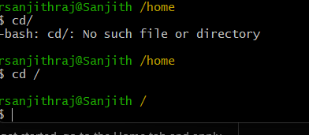

**File System**

1. **How to identify the file system:**
   * **Command Name**: df
   * **Syntax**: df -T
   * **Example**: df -T
   * **Description**: Shows the file system type of each mounted filesystem.

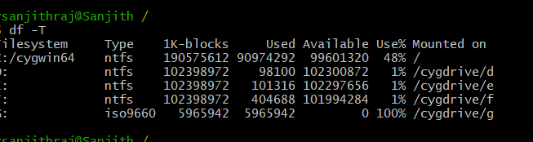

1. **Create Folder “CYS”:**
   * **Command**: mkdir CYS
   * **Description**: Creates a folder named "CYS".

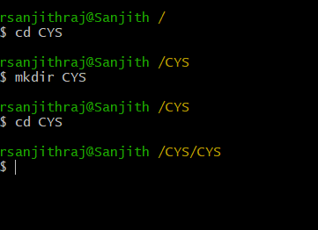

1. **Navigate to CYS:**
   * **Command**: cd CYS
   * **Description**: Navigates to the "CYS" directory.



1. **Create folder LS1 and LS2 under CYS:**
   * **Command**: mkdir LS1 LS2
   * **Description**: Creates folders named "LS1" and "LS2" under "CYS".

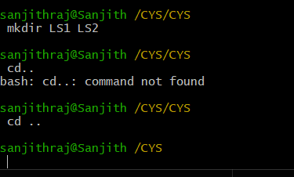

1. **Go back to CYS:**
   * **Command**: cd ..
   * **Description**: Navigates back to the "CYS" directory.



1. **Working with Files:**
   * **Add commands which you learnt during lab session in the file commands.txt:**
     + **Command**: echo "command" >> commands.txt
     + **Example**: echo "ls -la" >> commands.txt

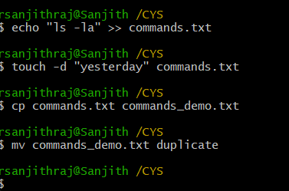

* + **Change the timestamp of the file to yesterday:**
    - **Command**: touch -d "yesterday" commands.txt



* + **Copy the contents from the file commands.txt to commands_demo.txt:**
    - **Command**: cp commands.txt commands_demo.txt



* + **Rename the file commands_demo.txt to duplicate:**
    - **Command**: mv commands_demo.txt duplicate

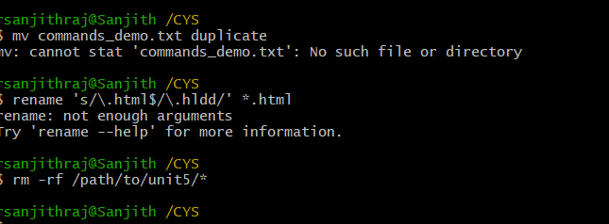

* + **Rename all .html to .hldd:**
    - **Command**: rename 's/\.html$/\.hldd/' *.html



* + **Delete the file duplicate:**
    - **Command**: rm duplicate

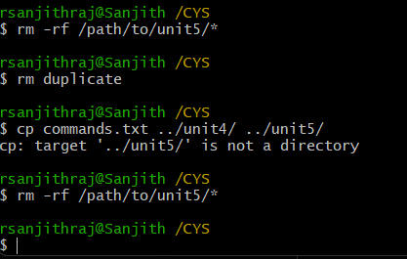

* + **Copy the contents of commands.txt to unit4 and unit5 (using relative path):**
    - **Command**: cp commands.txt ../unit4/ ../unit5/



* + **Delete the contents from unit5 (using absolute path):**
    - **Command**: rm -rf /path/to/unit5/*



1. **Navigate to root:**
   * **Command**: cd /
   * **Description**: Navigates to the root directory.

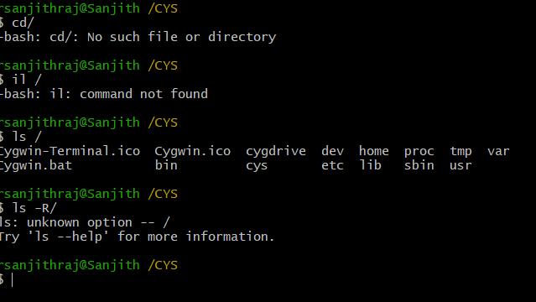

1. **List all the files under root:**
   * **Command**: ls /
   * **Description**: Lists all files and directories under the root directory.



1. **Explore all the folders (Do not delete any folder):**
   * **Command**: ls -R /
   * **Description**: Recursively lists all files and folders.



1. **Navigate to /etc/passwd:**
   * **Command**: cd /etc
   * **Description**: Navigates to the /etc directory.

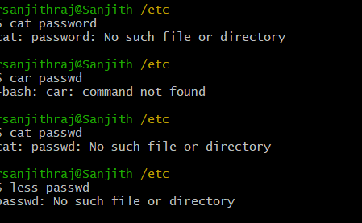

1. **Open the file passwd:**
   * **Command**: cat passwd
   * **Description**: Displays the contents of the passwd file.



1. **Explore the file passwd:**
   * **Command**: less passwd
   * **Description**: Allows you to scroll through the contents of the passwd file.



1. **Navigate to /etc/group and explore:**
   * **Command**: cd /etc && less group
   * **Description**: Navigates to the /etc directory and explores the group file using the less command.
   * 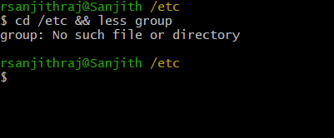

**Differences Between**

1. **GUI vs. CLI**:
   * **GUI (Graphical User Interface)**: Interfaces that allow users to interact with electronic devices using graphical icons and visual indicators.
   * **CLI (Command Line Interface)**: Interfaces that allow users to interact with the computer by typing commands into a terminal or console.
2. **man vs. info**:
   * **man**: Provides a manual page for commands with a focus on concise, specific information.
   * **info**: Provides more detailed and structured documentation, often including explanations, examples, and links to related topics.
3. **which vs. whereis**:
   * **which**: Shows the path to the executable of a command.
   * **whereis**: Locates the binary, source, and manual pages for a command.
4. **Terminal vs. Shell**:
   * **Terminal**: A terminal emulator that runs a shell and allows users to input commands.
   * **Shell**: The command-line interpreter that processes commands and returns the output.

**Simple Shell Script**

* **Task**: Write a simple shell script to print your name and your hobbies.
  + **Example Script**:

#!/bin/bash

echo "My name is [Your Name]"

echo "My hobbies are [Your Hobbies]"

* + **Save as**: myscript.sh
  + **Run using**: bash myscript.sh

**Interesting Commands to Explore**

1. **Banner**:
   * **Command Name**: banner
   * **Description**: Prints text as a large banner.
   * **Example**: banner Hello
2. **History**:
   * **Command Name**: history
   * **Description**: Displays the history of commands entered in the terminal.
   * **Example**: historyTop of Form

Bottom of Form